# Pipeline, CI/CD pipeline and Software Delivery Pipeline

## 1-pipeline

**# Source**: **Chatgpt (GPT-5-Standard) at [8/13/2025]**

In software development (especially DevOps), a **pipeline** is an **automated sequence of steps** that code goes through — from the moment a developer commits changes until it’s tested, built, and deployed to production (or another environment).

Think of it like an **assembly line** in a factory, but for software:

* Each stage performs a specific task (build, test, deploy).
* The output of one stage becomes the input for the next.
* If something fails at any stage, the process stops to prevent bad code from moving forward.

### Key Points About a Pipeline

**# Source**: **Chatgpt (GPT-5-Standard) at [8/13/2025]**

* **Automated** → Once triggered (e.g., when code is pushed), it runs without manual intervention.
* **Repeatable** → Same steps run every time, ensuring consistency.
* **Configurable** → You define the stages, tools, and order.
* **Integrated with CI/CD** → Pipelines make Continuous Integration and Continuous Delivery/Deployment possible.

### Typical Pipeline Stages

**# Source**: **Chatgpt (GPT-5-Standard) at [8/13/2025]**

1. **Source** – Detect code changes (commit, pull request).
2. **Build** – Compile the code, package it, and prepare artifacts.
3. **Test** – Run automated tests:  
   * Unit tests
   * Integration tests
   * API/UI tests
4. **Deploy** – Move code to staging or production environment.
5. **Post-Deployment Checks** – Smoke tests, monitoring, rollback if needed.

### Example – Simple CI/CD Pipeline

**# Source**: **Chatgpt (GPT-5-Standard) at [8/13/2025]**

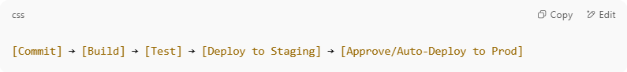

[Commit] → [Build] → [Test] → [Deploy to Staging] → [Approve/Auto-Deploy to Prod]

### Why Pipelines Matter

**# Source**: **Chatgpt (GPT-5-Standard) at [8/13/2025]**

* **Speed** – Changes can go from idea to production quickly.
* **Quality** – Automated tests ensure only working code moves forward.
* **Reliability** – Fewer human errors compared to manual deployments.
* **Feedback** – Developers know within minutes if their change broke something.

## 2-CI/CD pipeline

**# Source**: **Chatgpt (GPT-5-Standard) at [9/8/2025]**

A **CI/CD pipeline** is a set of **automated steps** that help teams build, test, and deliver software faster and with fewer errors.

It combines two main ideas:

### 1. CI → Continuous Integration

**# Source**: **Chatgpt (GPT-5-Standard) at [9/8/2025]**

* **Developers frequently merge (integrate) their code** into a shared repository.
* Every change triggers an **automatic build** and **automatic tests**.
* Goal: detect problems **early**, keep the codebase always working.

Example steps:

1. Developer pushes code.
2. Code is compiled/built.
3. Automated tests run (unit, integration, etc.).
4. If something breaks → alert the team immediately.

#### Integration

**# Source**: **Chatgpt (GPT-5-Standard) at [9/8/2025]**

In software/DevOps context, **Integration** means:

**Combining code changes from different developers, teams, or modules into a single shared build** — then making sure it all works together.

**🔹 Simple idea**

* Developers work on separate pieces (branches, modules).
* Eventually, those pieces need to **fit together**.
* **Integration** is the process of putting them together, building, and verifying that nothing breaks when combined.

**🔹 Types / contexts of integration**

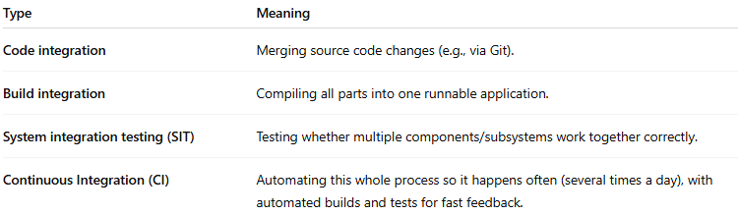

| **Type** | **Meaning** |
| --- | --- |
| **Code integration** | Merging source code changes (e.g., via Git). |
| **Build integration** | Compiling all parts into one runnable application. |
| **System integration testing (SIT)** | Testing whether multiple components/subsystems work together correctly. |
| **Continuous Integration (CI)** | Automating this whole process so it happens often (several times a day), with automated builds and tests for fast feedback. |

💡 In short:

**Integration** = putting the pieces together, early and often, to confirm that the whole system works as intended.

Would you like me to also explain how **integration** fits in the bigger picture (Integration → Delivery → Deployment → Release) in one flow?

#### automatic build

**# Source**: **Chatgpt (GPT-5-Standard) at [9/8/2025]**

An **automatic build** means: as soon as you change the code (for example, push to GitHub), a tool automatically takes care of turning that code into something usable — without you doing manual steps on your machine.

**In other words**

A “build” is the process of:

* **Fetching** the code and dependencies
* **Compiling** it (if needed)
* **Running scripts** that prepare it (minifying, packaging, etc.)
* **Producing** output (an executable, a web app bundle, a Docker image, etc.)

When it’s **automatic**:

* A CI/CD tool (like Jenkins, GitHub Actions, GitLab CI, Azure DevOps, etc.) does it for you.
* It triggers every time there’s a code change — no waiting, no manual clicking.
* It ensures everyone always works with a clean, fresh, consistent build.

💡 Quick example:

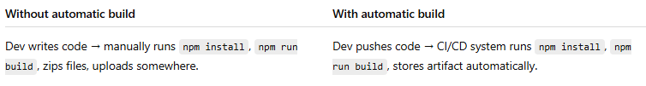

| **Without automatic build** | **With automatic build** |
| --- | --- |
| Dev writes code → manually runs npm install, npm run build, zips files, uploads somewhere. | Dev pushes code → CI/CD system runs npm install, npm run build, stores artifact automatically. |

#### automatic test

**# Source**: **Chatgpt (GPT-5-Standard) at [9/8/2025]**

An **automatic test** (or **automated test**) means: a program checks whether your software works as expected — **by itself**, without a person manually clicking or typing.

**In simple terms**

* Instead of a tester opening the app and trying every button,
* You write **test scripts** once (code that simulates what a user or system would do).
* A tool runs these scripts automatically (often right after the automatic build).
* If something fails, the system shows a **red flag** immediately.

**Typical kinds of automated tests**

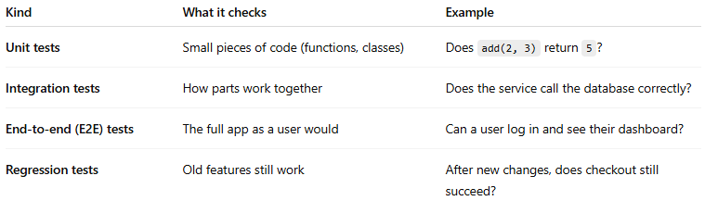

| **Kind** | **What it checks** | **Example** |
| --- | --- | --- |
| **Unit tests** | Small pieces of code (functions, classes) | Does add(2, 3) return 5? |
| **Integration tests** | How parts work together | Does the service call the database correctly? |
| **End-to-end (E2E) tests** | The full app as a user would | Can a user log in and see their dashboard? |
| **Regression tests** | Old features still work | After new changes, does checkout still succeed? |

💡 **Why it’s important**

* Finds bugs **early** and **fast**
* Saves a lot of manual work
* Works the same every time (no human mistakes)
* Fits perfectly into a CI/CD pipeline → after **automatic build**, you run **automatic tests** to make sure the build is safe to deploy.

#### CI promotes

**# Source**: **Chatgpt (GPT-5-Standard) at [9/8/2025]**

In Continuous Integration (**CI**), the word **“promote”** usually means:

➡️ **Moving a build, artifact, or code change from one stage to the next** in the delivery pipeline.

**🔹 Example in CI/CD**

1. Developer commits code → CI builds it.
2. The build **passes tests** → it gets **promoted** to the next environment:
   * From **dev → test**
   * From **test → staging**
   * From **staging → production**

So **promotion** = saying *“this build is good, let’s advance it forward.”*

**🔹 When people say “CI promotes …” they usually mean:**

* CI **promotes code quality** → because it enforces frequent testing.
* CI **promotes automation** → less manual effort.
* CI **promotes rapid feedback** → developers know quickly if something broke.
* CI **promotes reliable releases** → builds are tested at each step before promotion to production.

💡 **In short:**

In CI, “promote” means either *moving builds forward* in the pipeline or *encouraging better practices* like quality, automation, and fast feedback.

#### CI promotes shift left

**# Source**: **Chatgpt (GPT-5-Standard) at [9/8/2025]**

When people say **“CI promotes shift left”**, they mean:

* **CI** (Continuous Integration) encourages **testing and quality checks to happen earlier** in the software development process — i.e., “to the left” on the typical left-to-right timeline (plan → code → build → test → release → operate).
* Instead of waiting until the QA or staging phase to discover problems, CI runs automated builds, tests, static analysis, security scans, etc., **immediately** after each code change is integrated.

**🖼️ Simple way to see it**

* **Old way** → code a lot → then test at the end → find problems late (costly to fix).
* **Shift left** → integrate and test small changes all the time → find and fix issues early (cheaper, faster).

💡 In other words:

CI **promotes** (encourages, supports) the **shift-left** approach by making early integration, automated testing, and fast feedback normal practice.

#### CI Frameworks

**# Source**: **Chatgpt (GPT-5-Standard) at [9/10/2025]**

**🔄 CI Frameworks — Definition**

**CI** stands for **Continuous Integration**. A **CI framework** is the combination of **tools, scripts, pipelines, and practices** that allow developers to:

* Automatically **build**,
* **Test**, and
* **Integrate** code changes into a shared repository **frequently** (often multiple times a day).

In other words: a CI framework is the setup that automates the process of checking that every code change works well with the rest of the codebase.

**🔹 Why CI frameworks are important**

* **Early defect detection** — integration issues are caught as soon as code is merged.
* **Faster feedback** — developers know within minutes if a change breaks something.
* **Better collaboration** — encourages smaller, frequent commits rather than big risky merges.
* **Foundation for Continuous Delivery (CD)** — automated deployment and releases depend on good CI.

**🔹 Examples of popular CI frameworks / tools**

* **Jenkins** — open-source automation server; highly customizable.
* **GitHub Actions** — native CI/CD in GitHub repositories.
* **GitLab CI/CD** — integrated pipelines in GitLab.
* **CircleCI** — cloud-based, scalable CI/CD.
* **Travis CI** — popular with open-source projects.
* **Azure DevOps Pipelines** — Microsoft’s CI/CD solution.
* **Bamboo** — Atlassian’s CI/CD server (integrates with Jira, Bitbucket).
* **TeamCity** — JetBrains’ CI/CD platform.

**🔹 What a CI framework usually does**

1. **Triggers on code changes** (push, pull request, merge).
2. **Checks out** the latest code.
3. **Builds** the application (compiles, packages).
4. **Runs automated tests** (unit, integration, maybe UI).
5. **Generates reports** (test results, code coverage, linting).
6. **Notifies** the team (success or failure).
7. *(Optional)* **Deploys** to a test/staging environment.

💡 **In simple terms:**  
A CI framework is the **automated backbone** that makes sure every new piece of code is built and tested **quickly, consistently, and safely** before it becomes part of the main product.

### 2. CD → Continuous Delivery / Continuous Deployment

**# Source**: **Chatgpt (GPT-5-Standard) at [9/8/2025]**

* **Delivery**: The system can automatically package the software and prepare it for release. Someone still approves the final deployment.
* **Deployment**: The system goes further — it automatically deploys every passing build straight to production.

Example steps:

1. Package the application (e.g., Docker image).
2. Deploy to a staging (test) environment.
3. Run more tests (e.g., end-to-end tests).
4. (Delivery) Wait for human approval.
5. (Deployment) Automatically release to production.

💡 Summary (easy words):

A CI/CD pipeline is like a **factory line** for software:

* Code goes in → automatically built, tested, packaged, and (optionally) deployed.
* It saves time, reduces errors, and makes releases safe and frequent.

#### package the software

**# Source**: **Chatgpt (GPT-5-Standard) at [9/8/2025]**

When we say **“package the software”**, we mean:

Taking all the pieces of your application (code, compiled files, configurations, assets, dependencies) and putting them together in a **single deliverable unit** that’s ready to deploy or distribute.

**In practical terms**

Depending on the technology, the “package” could be:

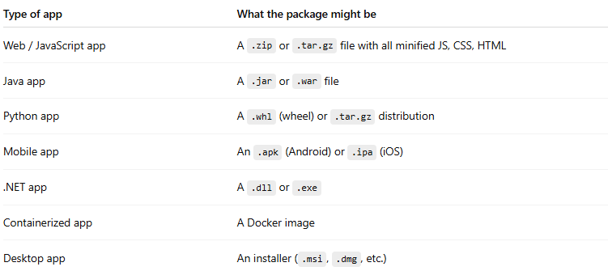

| **Type of app** | **What the package might be** |
| --- | --- |
| Web / JavaScript app | A .zip or .tar.gz file with all minified JS, CSS, HTML |
| Java app | A .jar or .war file |
| Python app | A .whl (wheel) or .tar.gz distribution |
| Mobile app | An .apk (Android) or .ipa (iOS) |
| .NET app | A .dll or .exe |
| Containerized app | A Docker image |
| Desktop app | An installer (.msi, .dmg, etc.) |

**Why do we package?**

* **Consistency** → same thing goes to every environment (test, staging, production)
* **Portability** → you can move the package between machines/servers
* **Versioning** → you can store each build (e.g., myapp_v1.2.3.zip)
* **Speed** → deployment is just dropping the package in place, no rebuilding needed

💡 In a CI/CD pipeline, this usually happens **after**:

1. **Automatic build** → compile and assemble the app
2. **Automatic tests** → verify it works
3. **Package** → create the deployable artifact
4. **Deploy** → move that artifact into a test or production environment

#### Delivery

**# Source**: **Chatgpt (GPT-5-Standard) at [9/8/2025]**

In software / DevOps terms, **Delivery** usually means:

**Getting changes safely from development into a state where they are ready to be deployed and used** — the entire process of building, testing, packaging, and preparing software for release.

**🖼️ Quick breakdown**

| **Term** | **Focus** | **Where it ends** |
| --- | --- | --- |
| **Integration** | Merging code changes frequently and testing them together | Verified build exists |
| **Delivery** | Making sure the verified build can be packaged, tested, and is **ready** for deployment at any time | The build is deployable |
| **Deployment** | Actually putting that build into a specific environment (test, staging, production) | Software is running there |
| **Release** | Making the deployed software available to end users | Users can interact with it |

**🚀 Related terms**

* **Continuous Delivery (CD)** → Automating everything up to the point where a version can be deployed **at any time** (but a human might trigger it).
* **Continuous Deployment** → Takes it one step further — deployments happen **automatically** after passing all tests.

💡 In short:

**Delivery** = The whole process of taking code from developers and preparing it so it’s **deployable** (safe, tested, packaged).

Would you like me to give you a super simple analogy (e.g., like pizza delivery 🍕) for CI, delivery, deployment, and release?

#### Deployment

**# Source**: **Chatgpt (GPT-5-Standard) at [9/8/2025]**

In software terms, **Deployment** means:

**Making a specific version of your software available in a particular environment (like test, staging, or production) so it can run and be used.**

**🔹 Simple explanation**

* You **build** your code → you get an artifact (like a .jar, .exe, container image, web app package, etc.).
* You **deploy** it → copy/install/configure it on servers, cloud instances, mobile stores, etc., where it can actually run.

**🔹 Common types of deployment**

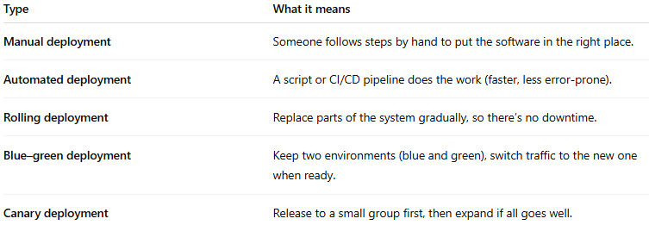

| **Type** | **What it means** |
| --- | --- |
| **Manual deployment** | Someone follows steps by hand to put the software in the right place. |
| **Automated deployment** | A script or CI/CD pipeline does the work (faster, less error-prone). |
| **Rolling deployment** | Replace parts of the system gradually, so there’s no downtime. |
| **Blue–green deployment** | Keep two environments (blue and green), switch traffic to the new one when ready. |
| **Canary deployment** | Release to a small group first, then expand if all goes well. |

💡 In short:

Deployment = taking a version of your application and **moving it into an environment** (often production) so that users or testers can **actually use it**.

Would you like me to also briefly explain the difference between **deployment** and **release** (they’re related but not the same)?

#### Environment types

**# Source**: **Chatgpt (GPT-5-Standard) at [9/8/2025]**

Here you go 👍 — a list of the most common **environment types** you’ll see in software development and testing pipelines, with a quick note on what each is for:

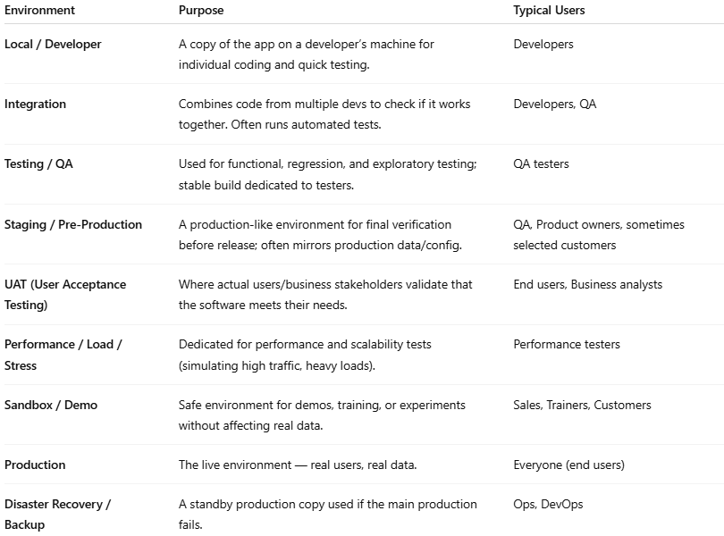

| **Environment** | **Purpose** | **Typical Users** |
| --- | --- | --- |
| **Local / Developer** | A copy of the app on a developer’s machine for individual coding and quick testing. | Developers |
| **Integration** | Combines code from multiple devs to check if it works together. Often runs automated tests. | Developers, QA |
| **Testing / QA** | Used for functional, regression, and exploratory testing; stable build dedicated to testers. | QA testers |
| **Staging / Pre-Production** | A production-like environment for final verification before release; often mirrors production data/config. | QA, Product owners, sometimes selected customers |
| **UAT (User Acceptance Testing)** | Where actual users/business stakeholders validate that the software meets their needs. | End users, Business analysts |
| **Performance / Load / Stress** | Dedicated for performance and scalability tests (simulating high traffic, heavy loads). | Performance testers |
| **Sandbox / Demo** | Safe environment for demos, training, or experiments without affecting real data. | Sales, Trainers, Customers |
| **Production** | The live environment — real users, real data. | Everyone (end users) |
| **Disaster Recovery / Backup** | A standby production copy used if the main production fails. | Ops, DevOps |

#### Release

**# Source**: **Chatgpt (GPT-5-Standard) at [9/8/2025]**

In software terms, a **Release** is:

**The act of making a specific version of your software available to its intended users.**

**🔹 Key points**

* A release is about **availability**, not just technical deployment.
* You can deploy code to servers, but if users can’t access or use the new features yet, it’s **not** released.
* In modern DevOps, deployment and release are often decoupled — you might deploy features behind a “feature flag” and **release** them later.

**🔹 How it fits with the other terms**

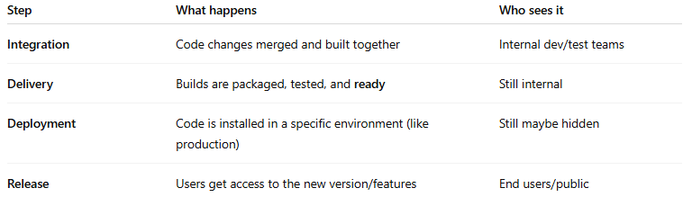

| **Step** | **What happens** | **Who sees it** |
| --- | --- | --- |
| **Integration** | Code changes merged and built together | Internal dev/test teams |
| **Delivery** | Builds are packaged, tested, and **ready** | Still internal |
| **Deployment** | Code is installed in a specific environment (like production) | Still maybe hidden |
| **Release** | Users get access to the new version/features | End users/public |

💡 In short:

**Release** = when a particular software version or feature is **officially launched** for use by its target audience.

Would you like me to create a **one-line analogy** (like pizza 🍕) for each — Integration, Delivery, Deployment, and Release — to make them easier to memorize?

## 3-Software Delivery Pipeline

**# Source**: **Chatgpt (GPT-5-Standard) at [8/13/2025]**

A **software delivery pipeline** is the **end-to-end automated process** that takes code from development all the way to production, ensuring it’s **built, tested, and deployed** in a consistent and reliable way.

It’s essentially the **full path your software follows** — from a developer’s commit to a running, usable product for end users.  
 If a *CI/CD pipeline* is like an assembly line for each change, the *software delivery pipeline* is the **entire manufacturing plant**, covering all stages from code to customer.

### Key Characteristics

**# Source**: **Chatgpt (GPT-5-Standard) at [8/13/2025]**

* **End-to-end**: Starts with source code changes and ends with deployed software.
* **Automated**: Minimal manual steps to reduce errors and speed up releases.
* **Integrated with CI/CD**: Continuous Integration (CI) + Continuous Delivery/Deployment (CD) stages.
* **Repeatable & Reliable**: Produces consistent results every time.

### Typical Stages in a Software Delivery Pipeline

**# Source**: **Chatgpt (GPT-5-Standard) at [8/13/2025]**

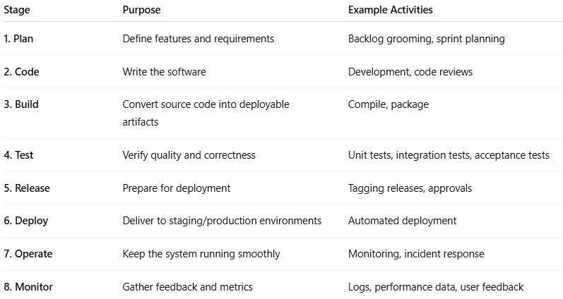

|  |  |  |
| --- | --- | --- |
| **Stage** | **Purpose** | **Example Activities** |
| **1. Plan** | Define features and requirements | Backlog grooming, sprint planning |
| **2. Code** | Write the software | Development, code reviews |
| **3. Build** | Convert source code into deployable artifacts | Compile, package |
| **4. Test** | Verify quality and correctness | Unit tests, integration tests, acceptance tests |
| **5. Release** | Prepare for deployment | Tagging releases, approvals |
| **6. Deploy** | Deliver to staging/production environments | Automated deployment |
| **7. Operate** | Keep the system running smoothly | Monitoring, incident response |
| **8. Monitor** | Gather feedback and metrics | Logs, performance data, user feedback |

### Example Flow

**# Source**: **Chatgpt (GPT-5-Standard) at [8/13/2025]**

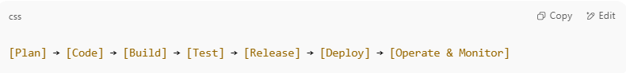

[Plan] → [Code] → [Build] → [Test] → [Release] → [Deploy] → [Operate & Monitor]

In modern DevOps:

* Each commit triggers **automated builds and tests**.
* If all checks pass, the code is **automatically deployed** to staging or production.
* Continuous monitoring feeds back into the next planning cycle.

### Why It’s Important

**# Source**: **Chatgpt (GPT-5-Standard) at [8/13/2025]**

* **Faster delivery**: Shortens time from idea to user.
* **Higher quality**: Testing is built in, catching issues early.
* **Better collaboration**: Developers, testers, and operations work as one team.
* **Lower risk**: Small, frequent releases are less risky than big-bang deployments.